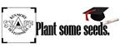
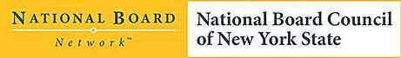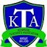

Candidate Support for National Board Certification

Now more than ever teachers must prove themselves in a constantly changing education landscape. The purpose of this course is to provide an understanding of the standards and skills needed to become a Nationally Board Certified Teacher. Participants will be asked to design, plan, and implement lessons that truly impact student learning. The lessons will incorporate specific standards; utilize technology such as Swivl and Google; develop professional writing skills; and examine professional responsibilities.
Cohorts for National Board offer an opportunity for sustained and collaborative support to teachers pursuing National Certification. Under the guidance of NBCTs as candidate support providers, this program is structured with a mini-lesson, followed by group interaction and discussion, independent work time, and a reflective writer’s workshop. We offer peer review, linkage with content experts, and collegial support. This group will meet monthly throughout the year. Attendance at every session is not mandatory. Bring your laptop.
Instructors: Laura Howse, NBCT and CSP; Amy Klose, NBCT and CSP; and Kathleen Reiser, NBCT and CSP.
Meeting Dates: October 5; October 19; November 16; December 8; January 18; February 16; March 22; April 20; and May 3.
Time: 4:30- 7:30 pm
All sessions to be held at the Sheridan Building 3200 Elmwood Ave., Kenmore NY
For more information contact : Kathy Reiser kreiser@ktufsd.org

